Statutory incidence: when the government makes a rule for the tax, they would decide who would be responsible in paying the tax (i.e., consumer or the store to pay the HST,)

Economic incidence: the government make a declaration that who should pay the tax, but the one finally gets economically affected may not be the one required to pay the tax. (i.e., seller may raise the price due to the tax, but consumers would finally afford such tax in fact)

Tax shifting: statutory incidence vs. economic incidence

Legally only people can bear taxes.

* Functional distribution of income: how tax make changes in distribution of input such as capital, labour, other economic production
* Size distribution of income: how tax make changes in distribution of overall income

Both sources and uses of income should be considered, it may depend on how one is using income.

Incidence depends on the disposition of tax revenues.

* Balance-Budget tax incidence: government takes tax revenue on something, we assume we could predict how much the government could get from tax, but it is usually tricky in practice.
* Differential tax incidence: one type of tax in place, and replace it with another, they would get same revenue, but what would happen to the economic.
* Lump-sum tax: tax not dependent on behavior of consumer, but on category of consumers.
* Absolute tax incidence:

Tax systems:

Average tax rate vs. marginal tax rate

Proportional tax system:



Average tax rate = amount taxed/total income

Marginal tax rate = the amount of tax received foe an extra unit of income

The marginal tax rate is never change in this case while the average tax rate may change as total income change.

Progressive tax system: the more you earn, the higher percentage the tax is.

Degree of a progressive tax system:

T1 = amount taxed at income I1

T0 = amount taxed at income I0

V1 is a way to evaluate how progressive it is.

V2 is used to measure the elasticity of tax rate, it is, the precent change

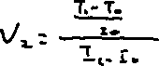

Regressive tax system

Unit tax: it is levied as a fixed amount per unit of a commodity sold, economic incidence does not depend on whether it is levied on consumers or producers, it depends

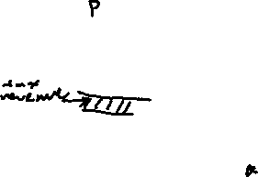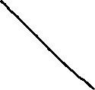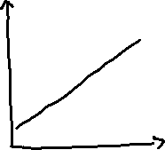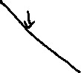

This is a tax on consumer, so the curve of demand change, it assumes that consumer only cares about how much they pay.

Similarly, we shift the supply curve upward if unit tax is applied to producers.

Tax incidence when supply is perfectly inelastic:

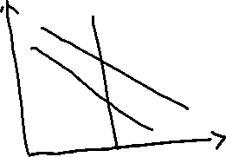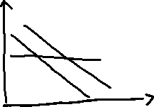

Ad Valorem Tax: a tax that is proportional to the price of the good (i.e., HST for 13%).

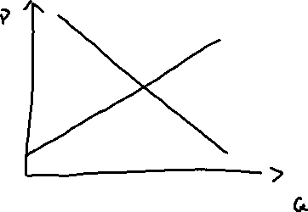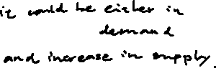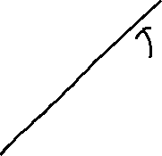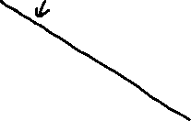

The payroll tax

So far: taxes on goods

* But analyss can also be applied to facto